Eric Dee

Data Concepts C

12/14/2020

During this exercise I learned that MySql doesn’t accept foreign keys that are composite keys in another table in any way that I could discern from the course materials. All of the requirements have been met, I just didn’t include as many foreign keys as we had discussed, because that was not possible. I spent approximately 12 hours working on this second version that I rewrote, and found a lot of unusable workarounds such as GENERATE ALWAYS AS, and other means of persisting the composite field which MySql did not accept.

It was a fun experiment, and I learned a lot about design standards as a result.

Attached to this document are the snapshots from the project, and within the zip it was included in are each command used to build and navigate the database successfully.

A.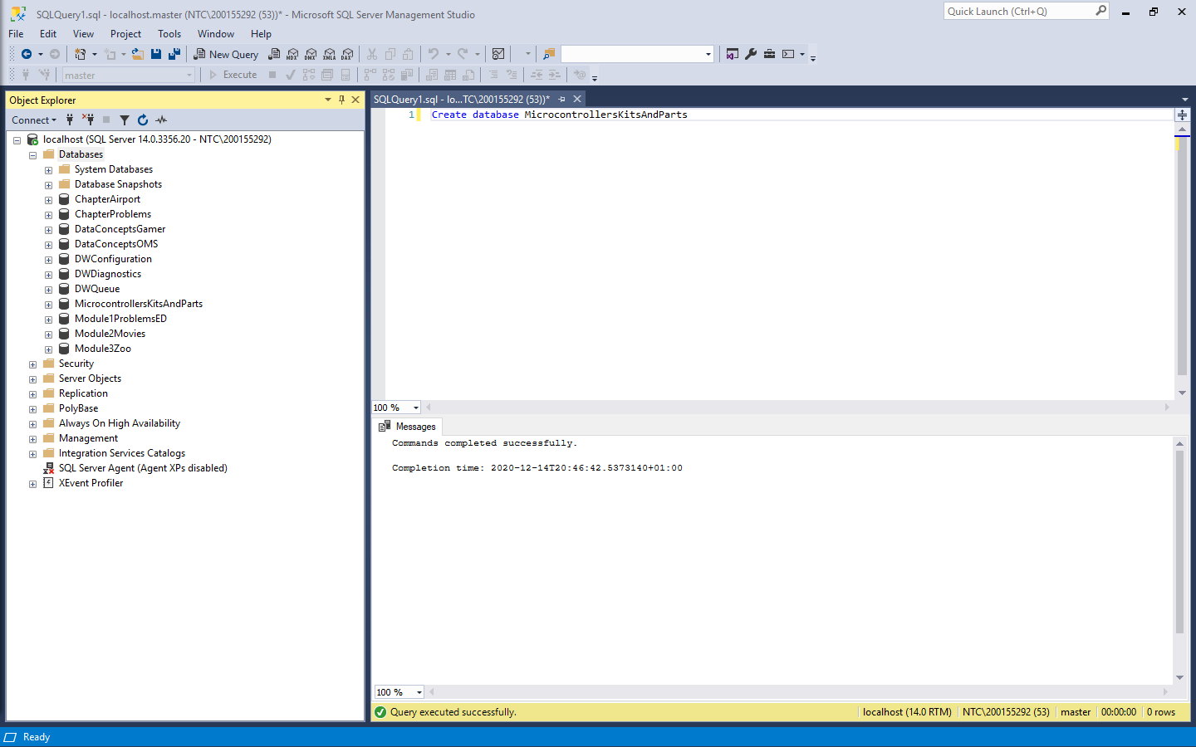

B.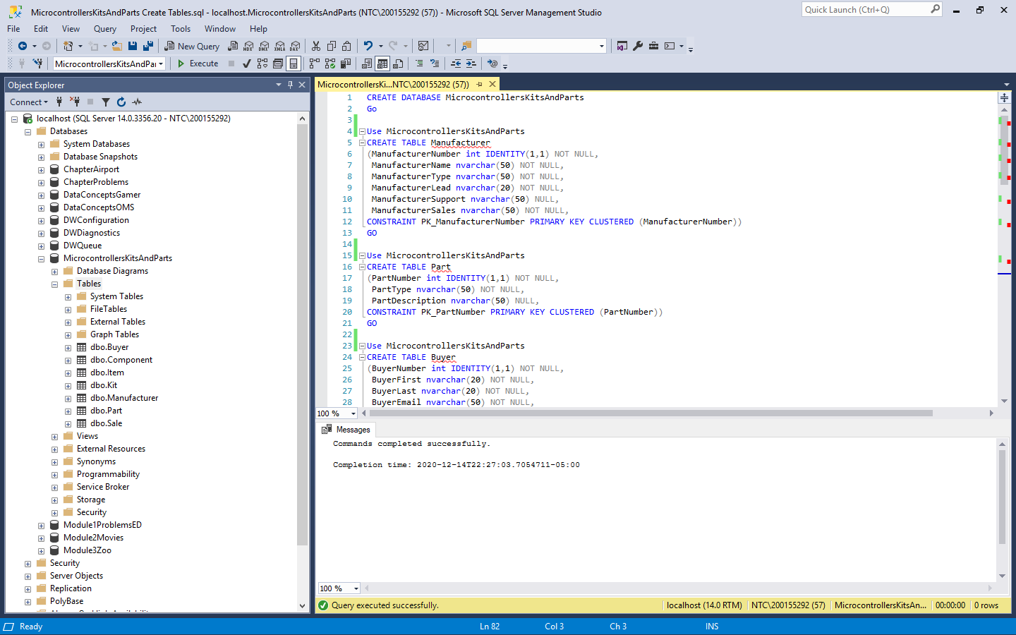

C.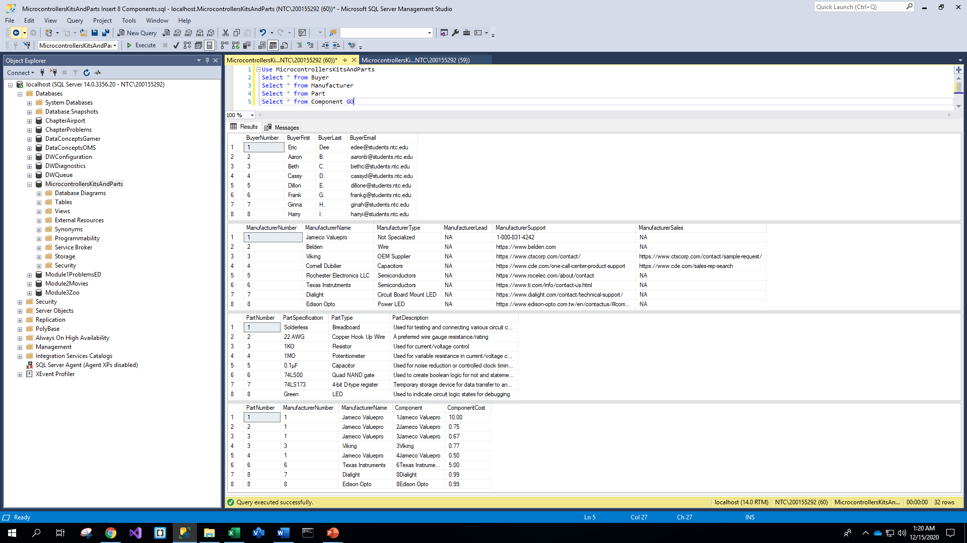

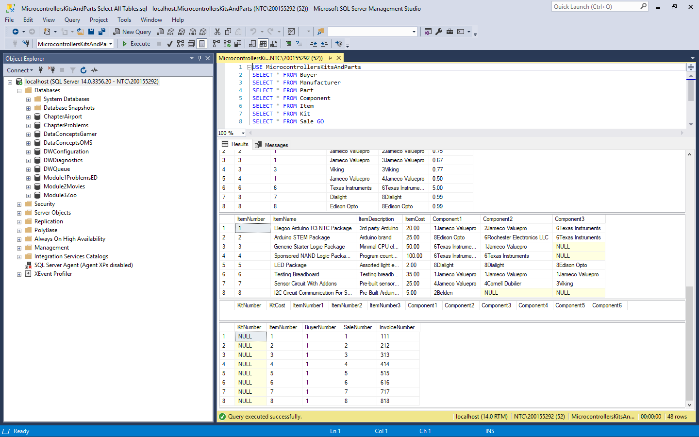

D.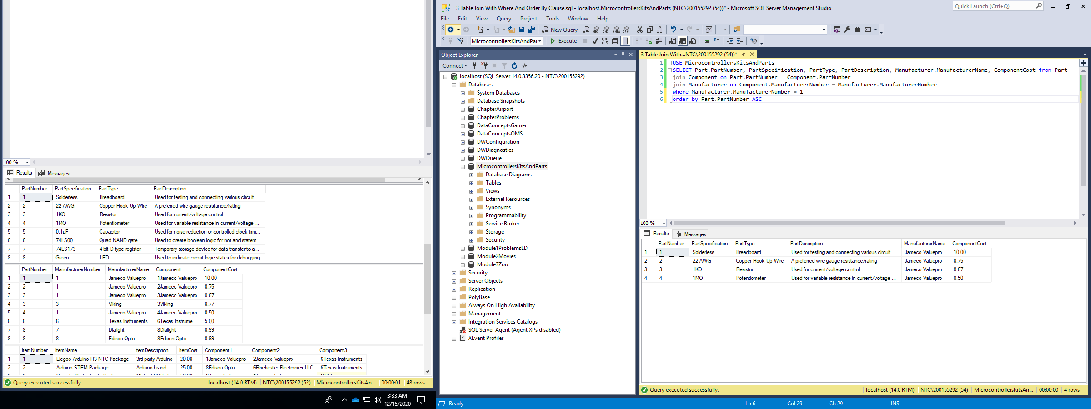

E.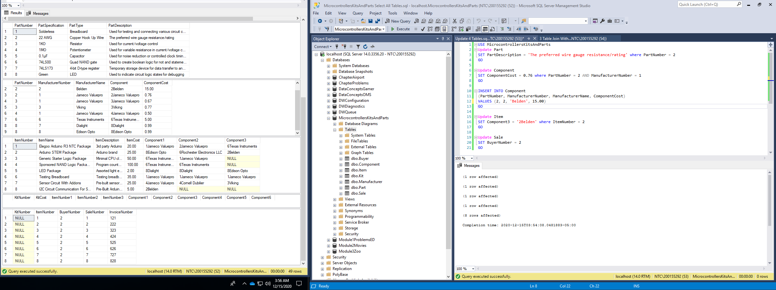

F.